EXPERIMENT NO. 7: ONLINE BEAUTY PARLOUR APPOINTMENT BOOKING SYSTEM
AIM:
To construct an online beauty parlour appointment booking platform that enables users to browse services, select beauty stylists, check real-time time slots, book appointments with online deposit payments, and manage salon schedules.
PSEUDOCODE (IN 6 SIMPLE POINTS):
Step 1: Initialize catalogue of parlour services (Hair Styling, Facial Glow, Spa & Massage, Bridal Makeup) with tariff and duration.
Step 2: Display stylist profiles with specialization ratings, customer reviews, and working shifts.
Step 3: Provide an interactive calendar date and slot selector that locks out occupied and unavailable hours.
Step 4: Authenticate the user and capture service selections, preferred stylist, and special aesthetic requirements.
Step 5: Compute bill with options for full payment or a partial 20% advance deposit via simulated payment gateway.
Step 6: Provide salon administrator dashboard to view scheduled reservations, update stylist availability, and issue client SMS reminders.
SOURCE CODE:
<!DOCTYPE html>
<html lang="en">
<head>
<meta charset="UTF-8">
<title>Glow & Glam Beauty Parlour</title>
<style>
body { font-family: 'Segoe UI', Tahoma, sans-serif; margin: 0; background: #fdf2f8; color: #374151; }
header { background: #db2777; color: white; padding: 25px; text-align: center; }
.container { max-width: 900px; margin: 25px auto; background: white; padding: 25px; border-radius: 12px; box-shadow: 0 4px 15px rgba(219,39,119,0.1); }
.services-list { display: grid; grid-template-columns: repeat(2, 1fr); gap: 15px; margin: 20px 0; }
.service-box { border: 2px solid #fbcfe8; padding: 15px; border-radius: 8px; cursor: pointer; transition: 0.3s; }
.service-box.selected { border-color: #db2777; background: #fdf2f8; }
.slot-grid { display: flex; flex-wrap: wrap; gap: 10px; margin: 15px 0; }
.slot-btn { padding: 8px 16px; border: 1px solid #db2777; background: white; border-radius: 20px; cursor: pointer; font-size: 13px; }
.slot-btn.active { background: #db2777; color: white; }
.slot-btn.disabled { background: #e5e7eb; border-color: #d1d5db; color: #9ca3af; cursor: not-allowed; }
button.book-btn { background: #db2777; color: white; font-weight: bold; border: none; padding: 12px 24px; border-radius: 6px; cursor: pointer; width: 100%; font-size: 16px; }
button.book-btn:hover { background: #be185d; }
</style>
</head>
<body>
<header>
<h2>Glow & Glam Luxury Salon</h2>
<p>Instant Real-Time Appointment & Stylist Booking</p>
</header>
<div class="container">
<h3>1. Select Services</h3>
<div class="services-list">
<div class="service-box" onclick="toggleService(this, 'Bridal Makeup Glow', 3500)">
<b>Bridal Makeup Glow</b> - Rs. 3,500 <br><small>Duration: 90 mins | Premium Cosmetics</small>
</div>
<div class="service-box" onclick="toggleService(this, 'Hair Spa & Keratin Polish', 1800)">
<b>Hair Spa & Keratin Polish</b> - Rs. 1,800 <br><small>Duration: 60 mins | Deep Conditioning</small>
</div>
<div class="service-box" onclick="toggleService(this, 'Aromatherapy Facial', 1200)">
<b>Aromatherapy Facial</b> - Rs. 1,200 <br><small>Duration: 45 mins | Organic Herbal Extracts</small>
</div>
<div class="service-box" onclick="toggleService(this, 'Manicure & Pedicure Deluxe', 900)">
<b>Manicure & Pedicure Deluxe</b> - Rs. 900 <br><small>Duration: 45 mins | Nail Care & Massage</small>
</div>
</div>
<h3>2. Choose Stylist & Appointment Date</h3>
<div style="display: flex; gap: 15px; margin-bottom: 15px;">
<select id="stylistSelect" style="flex: 1; padding: 10px; border-radius: 6px; border: 1px solid #cbd5e1;">
<option>Senior Stylist: Priya Sharma (Rating 4.9)</option>
<option>Master Colorist: Ananya Sen (Rating 4.8)</option>
</select>
<input type="date" id="bookDate" style="flex: 1; padding: 10px; border-radius: 6px; border: 1px solid #cbd5e1;">
</div>
<h3>3. Available Time Slots (Real-time Lockout)</h3>
<div class="slot-grid">
<button class="slot-btn active" onclick="selectSlot(this)">10:00 AM</button>
<button class="slot-btn" onclick="selectSlot(this)">11:30 AM</button>
<button class="slot-btn disabled">01:00 PM (Booked)</button>
<button class="slot-btn" onclick="selectSlot(this)">03:30 PM</button>
<button class="slot-btn" onclick="selectSlot(this)">05:00 PM</button>
</div>
<div style="background: #fdf2f8; padding: 15px; border-radius: 8px; margin: 20px 0;">
<p>Selected Services Total: <b>Rs. <span id="parlourTotal">0</span></b></p>
<label><input type="radio" name="payType" value="partial" checked> Pay Partial Deposit (30% Advance: Rs. <span id="depositAmt">0</span>)</label><br>
<label><input type="radio" name="payType" value="full"> Pay Full Amount</label>
</div>
<button class="book-btn" onclick="confirmAppointment()">Confirm Reservation & Pay</button>
<div id="bookingConfirmation"></div>
</div>
<script>
let chosenServices = [];
let chosenSlot = '10:00 AM';
function toggleService(box, name, fee) {
box.classList.toggle('selected');
if(box.classList.contains('selected')) {
chosenServices.push({ name, fee });
} else {
chosenServices = chosenServices.filter(s => s.name !== name);
}
let sum = chosenServices.reduce((acc, curr) => acc + curr.fee, 0);
document.getElementById('parlourTotal').innerText = sum;
document.getElementById('depositAmt').innerText = Math.round(sum * 0.3);
}
function selectSlot(btn) {
if(btn.classList.contains('disabled')) return;
document.querySelectorAll('.slot-btn').forEach(b => b.classList.remove('active'));
btn.classList.add('active');
chosenSlot = btn.innerText;
}
function confirmAppointment() {
if(!chosenServices.length) return alert('Please select at least one parlour service');
let date = document.getElementById('bookDate').value;
if(!date) return alert('Please select an appointment date');
let stylist = document.getElementById('stylistSelect').value;
let sum = chosenServices.reduce((acc, curr) => acc + curr.fee, 0);
let bRef = 'GLAM-' + Math.floor(1000 + Math.random()*9000);
document.getElementById('bookingConfirmation').innerHTML = `
<div style="margin-top:20px; padding:15px; background:#dcfce7; color:#15803d; border-radius:8px;">
<h4>Appointment Confirmed! Reference: ${bRef}</h4>
<p><b>Date & Time:</b> ${date} at ${chosenSlot} | <b>Stylist:</b> ${stylist}</p>
<p><b>Total Package:</b> Rs. ${sum} | <b>Confirmation SMS & Calendar Invite Sent!</b></p>
</div>`;
}
</script>
</body>
</html>
Output:
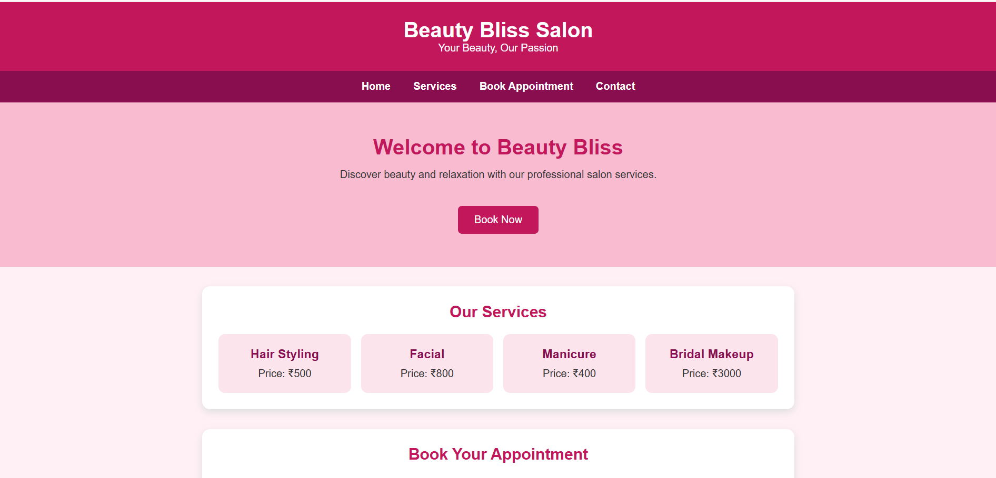
RESULT:
Thus, the online beauty parlour appointment booking system was successfully developed and tested, allowing dynamic service selection, real-time slot lockout, advance deposit payments, and booking verification.

